Incident Type: Choose an item. |  |  | Date: of Incident: |  | Time:
Name of person involved:
Phone:
Address of Incident:
Client/Resident : | ☐Yes ☐No
☐Yes ☐No | ☐Yes ☐No
Other: | ☐Yes ☐No
Staff member: | ☐Yes ☐No |  |  | Position: Choose an item.
Describe exactly what happened:

Injury to person if applicable:  Please describe injury/damage to property /equipment etc.: | Mark the location of the injury
 | 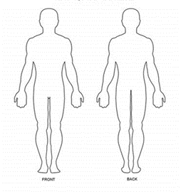

Please describe actions taken:
(including any medical care attended if applicable) :

Incident reported to:
Date: Tuesday, 14 December 2021 |  | Time: 12:17:57 PM
Name of reporter: |  | Position: Choose an item.
Name of person completing form: | Position: Choose an item.
Supervisor /Coordinator only

Incident:  Near Miss: |  |  | ☐Yes ☐No  ☐Yes ☐No
Is this a Reportable Incident to WorkSafe/Dept. of Health etc.?  List authority: |  |  | ☐Yes ☐No If yes, Call CEO immediately

Actions taken by Supervisor/Coordinator:
Date Incident entered into Carelink (if applicable):

Have any controls been initiated to prevent this incident occurring again? Please List:

Does this incident highlight a deficit?

Policy: | ☐Yes ☐No | Please list:
Education: | ☐Yes ☐No
Equipment: | ☐Yes ☐No
Resources: | ☐Yes ☐No
Other: | ☐Yes ☐No

Staff Injury: | ☐Yes ☐No ☐ N/A
Date of Follow up call to client/ staff member: |  | Time:
Outline their condition:

Date Notification of Injury Form completed and forwarded to Incident Mailbox ( incidents@mercyservices.org.au:

Name of coordinator/supervisor: | Position: Choose an item.
Date form completed:
Head of Department

Date Review by Head of Dept:
Name: |  | Position: Choose an item.
Further actions required:
Quality, Health & Safety Coordinator

Allocated Incident Number:
Is this an ongoing risk to be entered into Risk Register: |  |  | ☐Yes ☐No
Date Entered in Risk Register:
Further actions required:

